**CSCI 3000 Homework 5**

In this program, you will implement a simple inheritance relation between office items. We have the parent class “Item” and three child classes: “Pen”, “Folder”, and “Paper”. You will implement these 4 classes. Details of each class is given below:

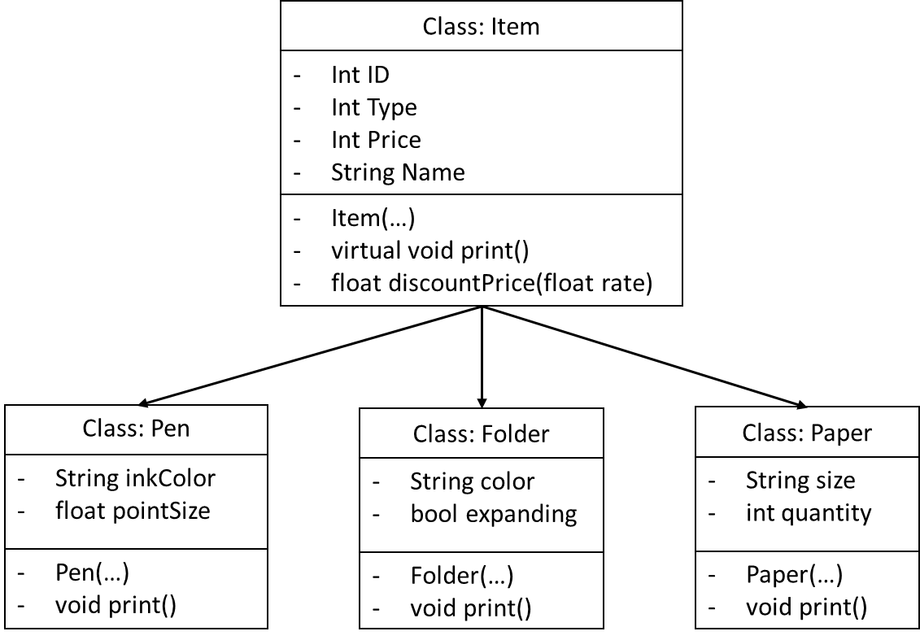

Item is the base class and it contains all common attributes and functions for all items. Each child class has two extra attributes and one print() function to print that item. Please note that print() function in the Item class is a virtual function.

Your responsibility is to create these four classes. To make your work easier, this time I do not expect you to separate each class into a different file. You will fill the “item.h” file template that is provided with homework description. And this time, I am not expecting an “item.cpp” file. You will write everything in the header file.

The main program (main.cpp) will also be provided to you. In the main program, all items are loaded into an item array by reading the file, and each item is printed with its discounted price. You do not need to make any changes on the main.cpp file.

Each class has a constructor function and a print function. Print functions should print all features of the item. Please see the next figure for a reference.

The discountPrice() function in the item class will calculate a discounted price of that item using the “rate” input. For example if the rate is 0.15, then the function will calculate price*(1-rate) and return result from the function.

Here is a sample output of the program. When you successfully fill the item.h file you should see a similar output as follows:

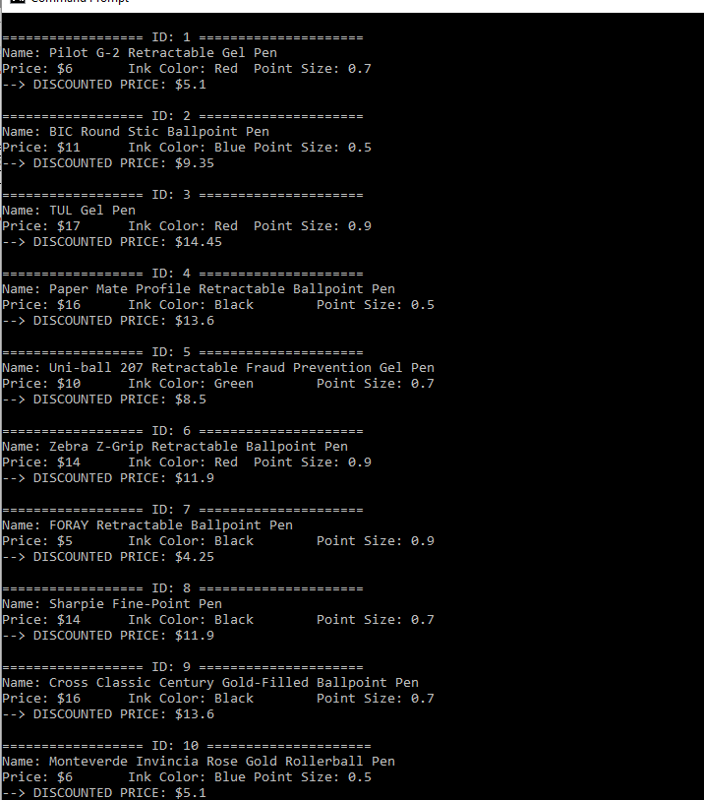

You will only submit your item.h file.

On the top of your source code, please add your name and number, Course ID, HW number and the date using a comment block. Please see the example below,

/*

Myname MySurname – MY_STUDENT_NUMBER

CSCI 3000, HW-X

(Due Date)

*/

Please do not copy your code from someone else’s program. The instructor may use a code comparison program that automatically checks the similarity between different programs. And do not hesitate to contact me if you are having trouble with the homework. I will be more than happy to help you to solve your problem.